General Meeting @ Waterworks Building

Thurs Oct 19, 2023, 7pm

- Welcome - Meet and greet – Members’ sign in—Call to order in-person meeting

Present: Tara Owen, Burry Gowen, Kim Williams, Gail Crocetta, Pat Crocetta, Scott Gordon, Allan Farquhar, Cara Farquhar, Pat Dobosz, Brendan Moore, Cathy White, Judy Rente, Chuck Crist, et.al.

- General Housekeeping
  - Introduced Brenda Swan from our host the St. Johns Cultural Council…reviewed upcoming events.
  - Conscious of your and guest speaker’s time – 1.5 hours, brief on OCSNA, Q&A David Birchim, new City Manager…topics asked him to address, then open up the floor, time permitting.
  - Introduce board: VP Brendan Moore, Treasurer Mark Brand, Sec’y Burry Gowen, Social & Membership Chair Gail Crocetta, Judy Rente and Allan Farquhar
  - 120 – Full & Assoc. memberships, of which 96 are paid up. 15 member hh present, which does NOT constitute a quorum.
    - To facilitate tracking membership and collecting payment
      - January membership drive…blanket the neighborhood…$20 no matter when you join…$10 for renters
      - We now have PayPal and Venmo as options linked directly to our account at Ameris, so you can mail a check, pay via the website, or use one of these apps.
  - We have $1,865 in the bank…before reimbursing potluck expenses. (website, subscriptions, wine, decorations, etc.)
  - General Membership mtgs 2x/yr 3rd Thurs. in October and the 3rd Thursday in March (3/21/24);
  - Active committees (Social, Membership, ad hoc St. Francis Park, Decorating)
    - Gail & Pat…share with you our social priorities
    - Fall and Spring Potlucks…monthly events (coffee, Dog Rose, W&W) and pop-ups (Book Club, Waterworks tour, flower arranging, poker)
  - Google Group—community bulletin board, picking up steam
    - Show of hands…how many of you log onto our website at oldcitysouth.org? NOT MANY
    - Google Group…most
  - Liaise with the city… perfect segue…residential permitted parking extended north to Artillery Lane, met frequently with Jessica Beach regarding the Lake Maria Sanchez project and the Army Corps back bay study, working with Oldest House and the City on the rehabilitation of St. Francis Park, King Street redevelopment (incl. construction at the Bridge of Lions and reconstruction of San Sebastian Bridge), updates on development, nightlife ordinance. This is a City that works…for its millions of visitors, but also for its residents.

- David Birchim – City Manager
  - Unanimously appointed City Manager by the City Commission in May, David Birchim brings a quarter century of experience working for the City of St. Augustine, most recently as Asst City Manager and before that Planning and Building Director.
  - As City Manager, he is the CEO of St. Augustine, supervising almost 400 employees and serves as the linchpin between the citizens of St. Augustine and the City Commission. All the city department heads, including, fire and police chiefs, report directly to David.
  - David’s background is in urban planning and public administration, appropriately. His alma mater is the University of Tennesee.
  - Thank you…questions…open the floor.

- Flood Mitigation – Lake Maria Sanchez Project
  - Q: Do we need to wait for appraisal of easements of south side properties on Maria Sanchez Creeks to begin project? Fear losing all of grant funding b/c of delay in obtaining right-of-way appraisals.
    - Jessica Beach would have specifics on appraisal status and grant conditions, but we are moving forward.
    - A: Phase 1 – Flooding along Cordova, Granada, and Bridge - Replacing all storm water lines and pushing storm water into river w/ tide check valves, Phase 2 – Barrier from Roxanne Horvath’s property (South and Washington) to Connor property and pump station at south end of Lake Maria Sanchez for when backs up to where tide check valves won’t work, pumps will pump water over barrier to buy time. Designed to respond to localized flooding situations.
    - $30M project – CoSA confident will complete. Goal to protect core of downtown south of the Plaza bringing sea wall to consistent 7’ elevation starting north of Marina. and extend south to National Guard property south of Council on Aging and wrap all the way around peninsula to connect to barrier at South Street.
    - Q: Can start on wall even before the property appraisals have come through? A: If properties south of Connor property don’t cooperate and give easements to City, City has Plan B. Connor property has been emptied, salvaged kitchen, air handlers. Will demolish before Christmas and turn into a passive park. But need to wait to schedule Phase II until we know if easements have come through. Can’t do stretch of bulkhead and then pause project.

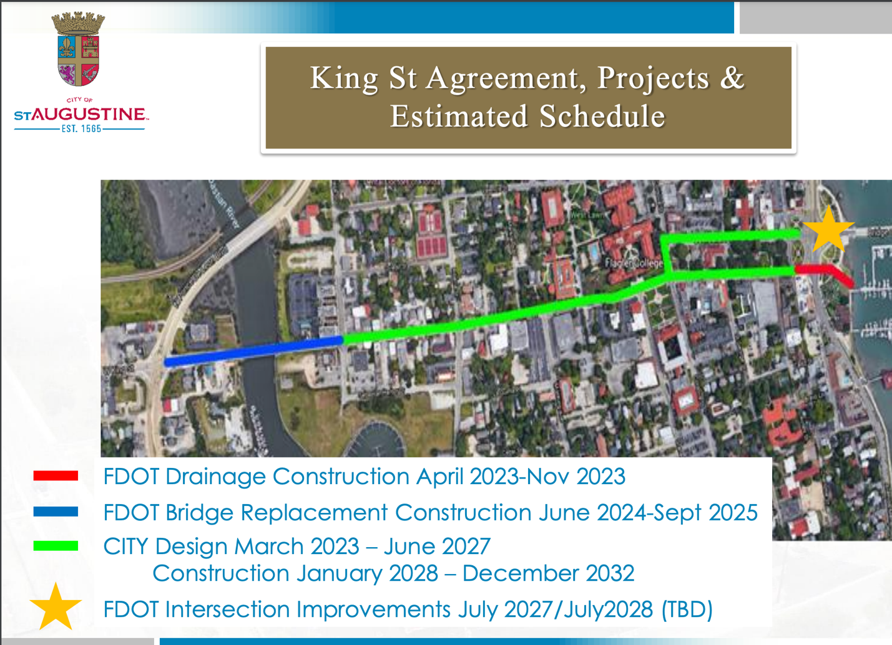

- Bridge of Lions intersection – July 2027 to July 2028
  - FDOT’s plan to change design of intersection on downtown
(west) side of Bridge of Lions (King St./Avenida Menendez/Cathedral Pl./Bridge of Lions)
  - Purpose of change: to stop traffic backing up on bridge.
  - Solution: Peanut design similar to peanut roundabout @ San Marco/W. San Carlos/ May St. (on the way to Vilano Bridge) intersection – Non-signalized intersection – intersection runs smoothly even if power goes out.
    - Public hearing @ City Hall 11/08 @ 4:30 pm
    - Q: If westbound over bridge, will we still be able to take left onto Avenida Menendez? A: Yes. Will go on roundabout and exit onto southbound Avenida Menendez
    - Construction will start July 2027. Completion July 2028
  - Current FDOT construction on King Street on track to be completed on time per Reuben Franklin. (before Nights of Lights) despite finding 19th century fishing vessel, which has been relocated to Lighthouse, site of archaeological restoration program.

- San Sebastian Bridge Replacement (blue):
  - Location: Summer 2024 - FDOT will remove bridge on King St. over San Sebastian River (just before King St./Ponce De Leon Blvd. (US-1S)) and replace with bridge of same size, same # of lanes but w/ decorative lights and wider sidewalks – 14+ mo. project
  - Impact: Will signalize intersection of Malaga St. and Ponce de Leon Blvd. During bridge replacement, traffic will be rerouted to use that intersection to access King Street and downtown. Malaga will be a bottleneck.
  - Bad news: We’ll have bottleneck to enter or exit Ponce de Leon to/from downtown.
  - Silver lining: during construction, very little tourist traffic through the neighborhoods
  - Q: Will bridge be taller b/c of flooding issue and structural support? If make steeper won’t be able to access driveway to Marriott? A: Tricky. now will do work on right of way approach on west side where it floods so it doesn’t pond up as it does now at high tide. Plan to fix drainage along with bridge replacement.
  - Q: Consider making bridge wider? A: Can’t because we don’t have the right-of-way, only own strip that bridge occupies currently

- King Street Re-design: City project. Commence 2028 – Finish 2032 (green)
  - Complete renovation of King Street. Widen. Put power underground. New light poles. New sidewalks. Similar to what City did on Riberia (where David Birchim lives)
  - Still on schedule

- HARB and alternative building materials (in HP districts):
  - Everything north of San Salvador St. is in Historic District. Question of alternative materials discussed earlier today as part of the revision of the AGHP (architectural guidelines for historic preservation), last revised in 2011.
  - Q: Who does HARB answer to? A: City Commission. CC appoints board members.
  - Q: Why does HARB not have term limits and no one on board who actually has to live under HARB decision? A: There are term limits. HARB board members can go through 2 consecutive terms, and you can also serve the remainder of someone else’s term who leaves board. And then you can go off board for 1 year and are eligible to serve two more 4 year terms (which explains why certain members have been on for most of the last 13 years).
  - If you want to change this, you need to get a city commissioner to sponsor an ordinance to redefine HARB board terms. There are qualifications to serve on HARB, but no one on board lives in HP 1. Some do live in other HP zones.
  - Qualifications for HARB can be found on city website. Certain professional categories need to be represented. If you want an ordinance requiring board to have someone from HP-1 always on board, you need to get a city commissioner to sponsor an ordinance to require a change in the composition of the board.
  - If HARB board member represents a client with business before board, he/she must recuse.

- Short Term Rentals: Presentation on Code Enforcement and STRs will be made at upcoming City Commission mtg.
  - Presentation is on the city website: -2023-10-23-STR Code Enforcement Update with maps
  - STRs everywhere; 744 registered but probably more than 1000 in city. Only 15,000 people live in town. Lincolnville overwhelmed.
  - Currently there is a required registration and safety inspection ordinance…parking spaces= # of BRs
    - Registration - challenge because ownership of STRs turns over so frequently.
    - Hotel occupancy going up now. @ tail of COVID good occupancy #s because people vacationed here (Florida stayed open). But now many tourists are going overseas for travel.
      - Hotel numbers beginning to stabilize to pre-COVID levels
      - In B&B industry (vacation rentals) – normally 52% occupancy (way below what is acceptable in hotels). Now has dropped down to 35%. Many new owners of STRs not able to make mortgage payments. Many now underwater so might cause many STRs to go back on market and.or become Long-Term Rentals.
      - Explosion of STRs = drop in affordable housing downtown
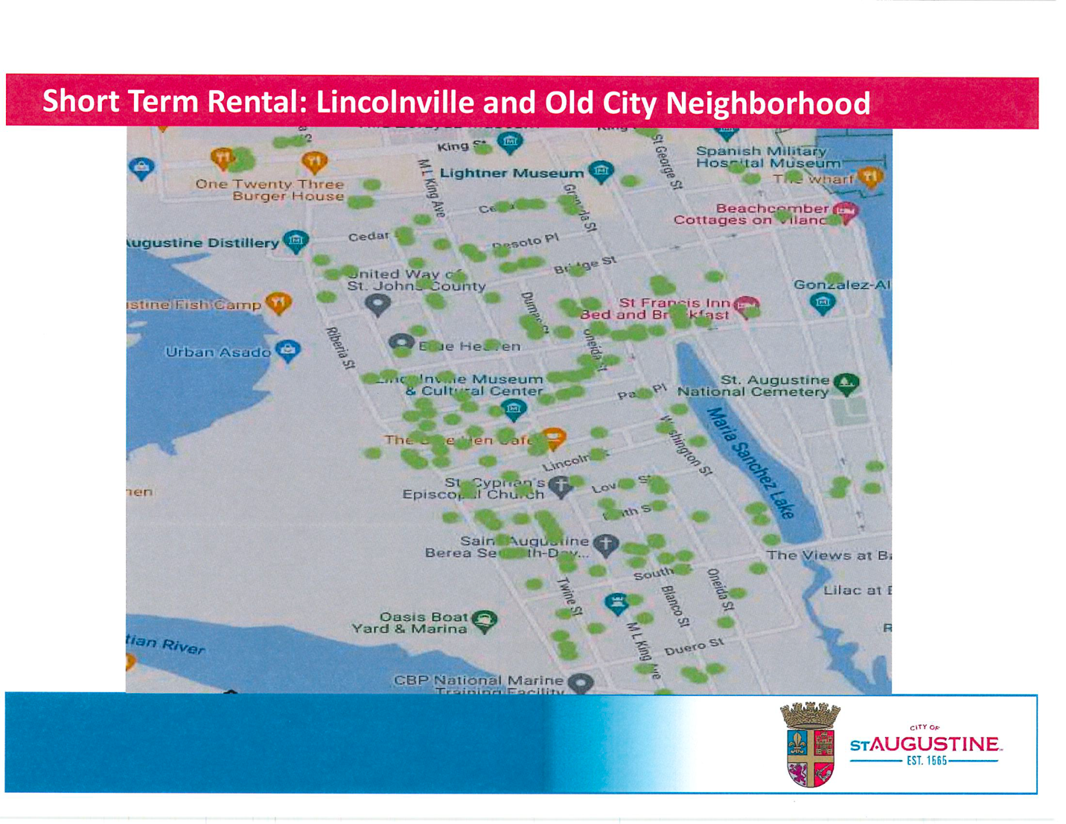
      - Staff of downtown restaurants and businesses who lived in Lincolnville can’t find affordable long-term rentals. Flagler students couldn’t find housing so Flagler had to buy hotel on Ponce de Leon Blvd.

- Homelessness – city has done land swap (1031 Starker exchange with property the City owned on Plantation Island Dr S.) for property at intersection of SR207 and S. Old Dixie Hwy (9092 S. Dixie Hwy – right behind Winn Dixie). Used to be trailer park called San Juan Trailer Park.
  - Property will be drop-in homeless day center
    - Homeless will be able to: take shower, get mail, wash clothes, apply for a job, get Social Security Card, arrange for bus transportation home – rather than hanging around downtown.
    - September 2023 did the swap.
    - Have contacted many umbrella organizations that provide funding for services for the homeless (e.g., Home Again-Dining with Dignity)
    - City doesn’t want to be in the housing business; won’t fund provision of services. Want to find private non-profit orgs already experienced in providing services and CoSA will lease space to them for cost of insurance and light bill.
    - Next steps:
      - Phase 1
        - Outreach officer already approved in budget.
        - Security/privacy fence will be constructed around property
        - Dining w/ Dignity will move from behind City Hall to this new location. Original agreement was for 8 mos behind City Hall…here we are 13 years later
      - Phase 2
        - Need to find out if buildings on property can be repurposed for services and possible housing or will buildings have to be demolished?
        - Historically this property floods
        - Development of new property will be in next year’s budget.
      - Q: Van to get homeless from downtown to the center? A: Yes
      - Q: Homeless population size vs. other cities? A: Depends on weather. Ebbs and flows: homeless communicate w/ each other to let each other know about environment and available services in various cities.
      - City policy to ask churches and businesses to give to United Way rather than panhandlers hasn’t been successful – tourists often give $; as they are on vacation and feeling generous.
      - On average: 27 homeless in Downtown Historic Dist. Rise and fall in #s depends on weather and storms, but also there is a local homeless population whose families have been here for generations (not going anywhere)
      - Q: St. Francis House provides transitional housing for homeless families in crisis: what is possibility SFH will be able to expand this to other homeless? A: Struggling to prove the services/beds they currently offer. No progress on the new building for women with children in crisis (not men)…still gutted and no workers. Single biggest reason Lincolnville is not completely gentrified is SFH.

- Development projects:
  - Corazon – French and Asian fusion restaurant at Corazon site now under construction
  - Sebastian Harbor Drive/San Sebastian River development
    - Marriott Tribute Hotel – on west side of King St. Bridge stalled b/c of supply chain issues (difficulty getting building and finish materials)
    - Sebastian Harbor Drive site (vacant prop behind Ice Plant stretching to San Sebastian Winery) will have:
      - New Marriott Hotel on Riberia
      - Current yacht marina on San Sebastian River will be redone; already started
      - Another resort adjacent to Marina
      - Stand-alone restaurant
      - Between resort and winery will be parking garage (On Sebastian Harbor Drive)
  - Sebastian Harbor Drive – City will redevelop w/ mobility fees from SHD development. Will fix dip on SHD that always floods.
  - Cigar Bldg on intersection of Riberia and King (Conti Patel) will be turned into boutique hotel.
  - Proposed distillery, dining, RR museum development denied on appeal.
  - Q: Has study been done on how many hotel beds needed? When is enough is enough? A: Free market decides. Commercial prop owners have zoning and deed entitlements. Hotel people want to be in St. Augustine. City can’t stop comm. prop owners who have right to build hotels from building hotels.
  - Q: Roads are really bad because of tourists A: Yes, majority of damage to roads is from people who don’t live here: tourists and St. Johns County residents who don’t live in St. Augustine. 15,000 people don’t put level of wear and tear on roads that they are receiving.
  - Q: What are mobility fees? A: Just introduced as a way to address this larger issue of recouping money for the wear and tear on our infrastructure.
    - CoSA doesn’t have impact fees.
    - When prop. owner develops property, pays utility connection charges (reservation of service: sewer lines, water lines) only so much capacity and CoSA keeps track. Can’t allow more connections until have capacity.
    - Used to be able to collect state traffic concurrency fees but now state requires CoSA to increase capacity (widen the road) if they charge fee. Not practical in dntn Saint Augustine b/c you’d have to tear down historic bldgs. to do it! Now use mobility fees. Can charge developers for intersection improvements, new sidewalks, ride share hubs and street improvements. Created fee schedule based on type of commercial development and introduced into our Comprehensive Plan 2 years ago.
    - Must show that mobility fee directly benefits developer who pays fee (can’t use the money to fix potholes in another neighborhood).
  - Broudy property - 11/13 City Commission mtg – review memorandum of understanding between CoSA and Barry Broudy (prop owner)
    - Agreement to build public parking garage on that site – 752 spaces
    - Rest of site – retail and multi-family plus Broudy Liquors
    - Currently working through details of memorandum, milestones to hit.
    - Afterwards, Broudy designs and builds development at own expense.
    - CoSA will pay back over 30-years to Broudy, at which point it will own the garage.
    - Was going to build pedestrian bridge over US-1. But goes over State right-of-way and FDOT feels they are already being overly generous. State said wait until King Street renovations are complete.

- Trolleys
  - Q: How regulated (routes, speed, #)? A: regulated and franchised by City, which assesses a fee. Just approved route down MLK to Lincolnville Museum. Attractions where they stop are paying trolleys to have them stop. Lincolnville Museum trolley will have 1 year and then will reevaluate impact.. Will exit on Lovett Street. If you want city to change routes need to get City Commissioner to sponsor ordinance to change the routes.
  - Unfranchised golf carts. Conveyances don’t have to be franchised if have < 8 passenger seats. City trying to update Vehicle-For-Hire Ordinance so that even if have less than 8 seats, may not have to be franchised but still will be regulated. Have engaged consultant (same as who helped city develop Mobility Plan) to reexamine Vehicle-For-Hire plan. Bringing trolleys into conversation. Trolleys being impacted by unfranchised golf carts. We don’t want get City into a law suit (costing lots of taxpayer dollars) for not regulating golf carts. Trolleys suggested city impose insurance requirements on golf carts above and beyond state requirements. Not sure if city can do that.
  - Golf carts engaging in all types of nonsense. Microphones, seating greater that 8, going all through the neighborhoods, some STRs have golf carts which add to the problem. Golf carts also ignore street flooded signs after extreme weather and nuisance flooding.
  - Q: can Neighborhood Associations meet with trolleys? Not answered.
  - Q: Flexible enough to have route changes during King Street construction? A: Yes during major construction there may be temporary route changes. But for major permanent route changes (e.g.,. not stopping at the Oldest House or putt-putt course) that would require ordinance change. It would be a big deal.

- Bike share program
  - Last Tuesday, all bike share racks removed. Company was called Gotcha. Went bankrupt. One of people working for them wanted to use existing racks but their own bikes. Gotcha had covered most expenses through sponsorships. (Advertising – bikes = rolling billboards). City told new guy that he had to provide a certain level of insurance and certain minimum requirements. He couldn’t do it and city waited but ultimately informed him, when he didn’t come through, that he had to remove the bike racks from city property. Would be happy to talk to him in the future when he gets together what he needs. St. Augustine appears to be too small for Bike Share Program to be viable.

